**Matlab HW2 Report**

**電機二 B09602017 白宗民**

**(a) Figure** x[n] vs. n :

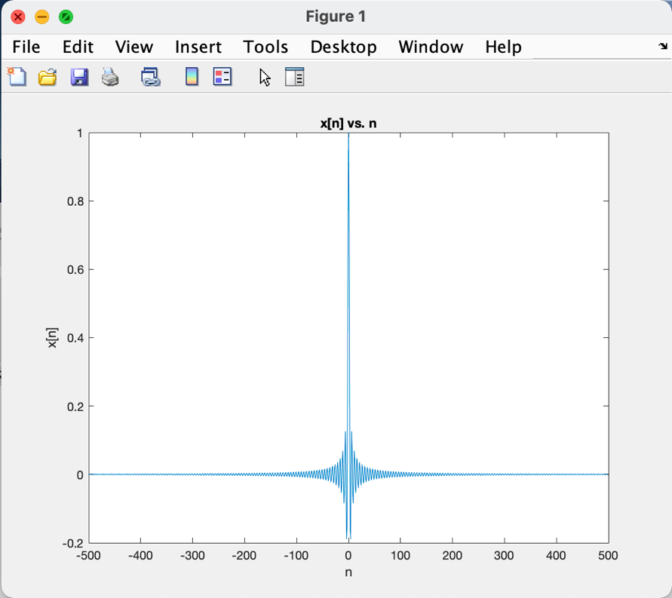

**(b) Figure** fft ouput vs. omega :

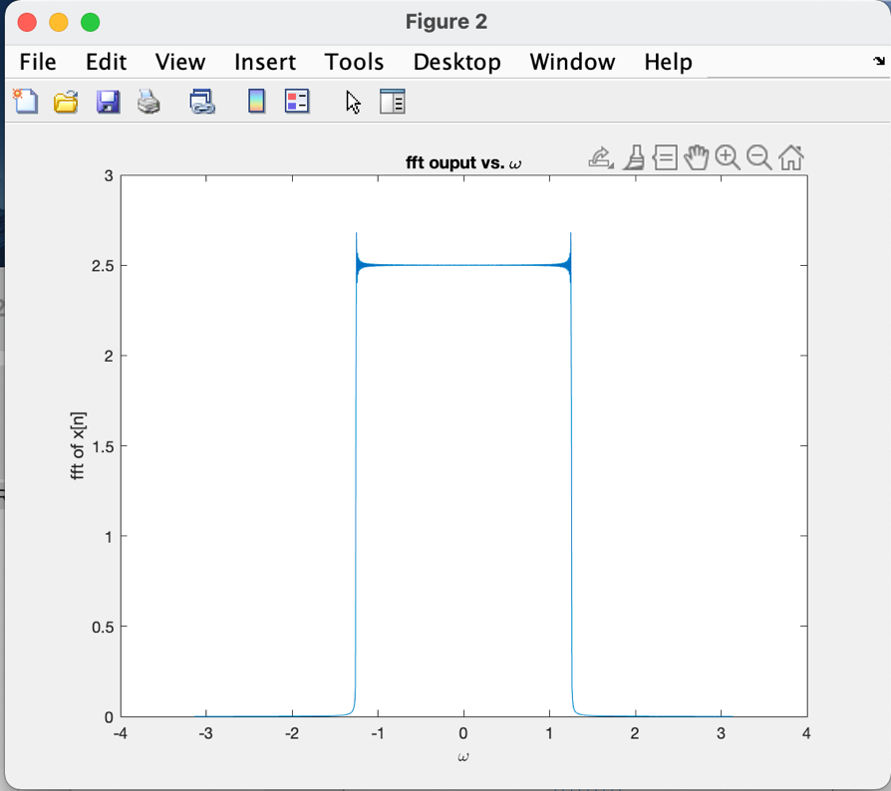

The Gibbs Phenomenon occurs here for it’s a discrete FT, and they are symmetric for their position and height of the ripples.

**(c) Figure** X_k[n] vs. omega :

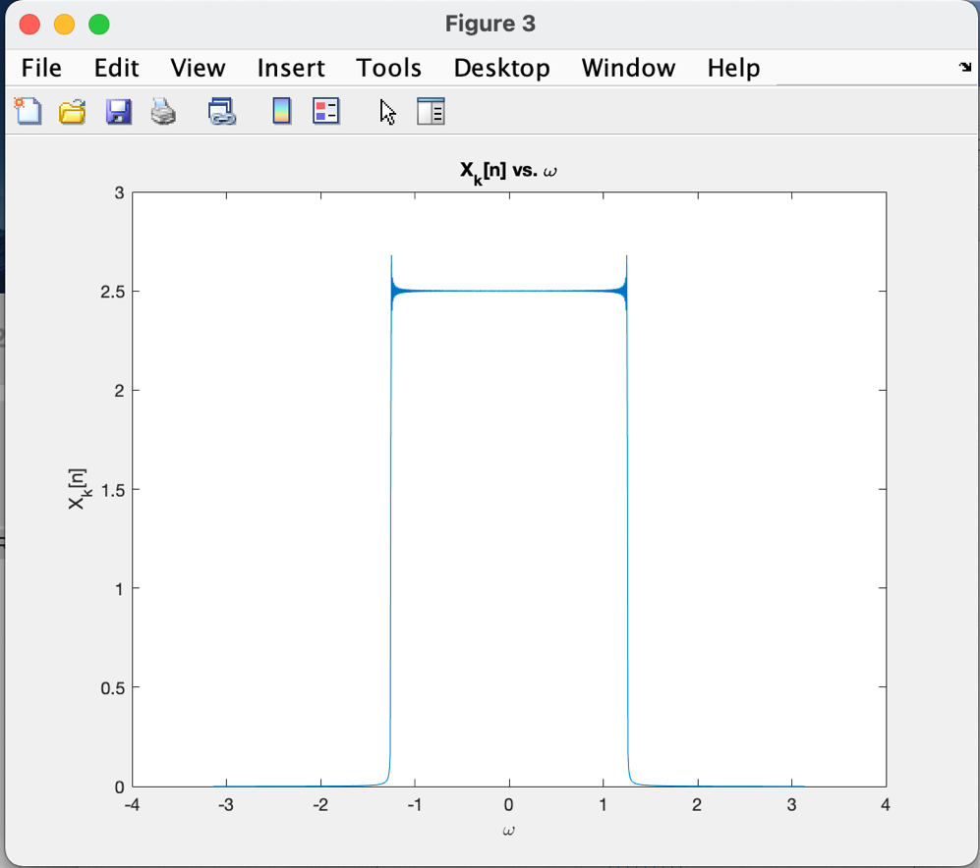

**(d) Figure** w[n] vs. n :

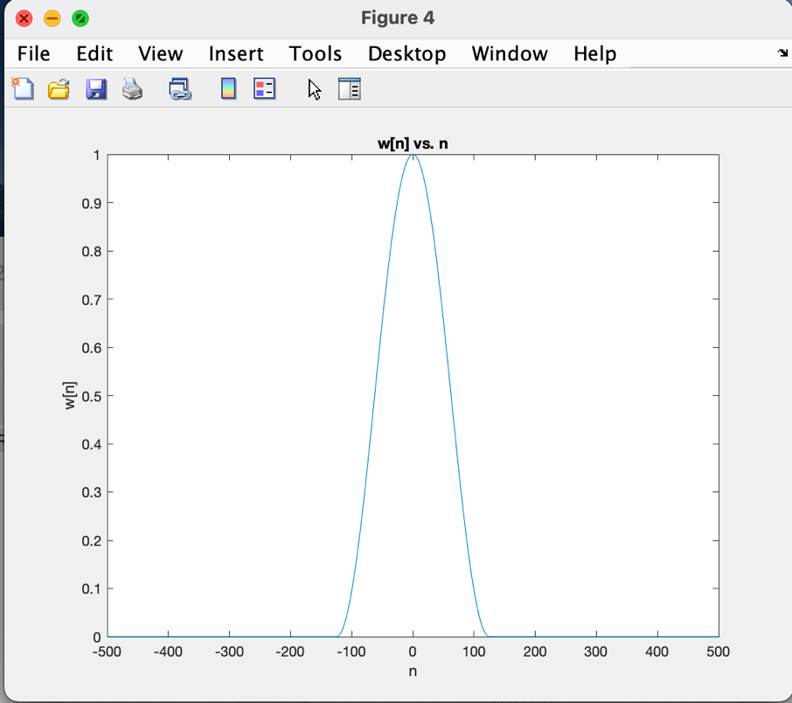

**(e) Figure** y[n] vs. n :

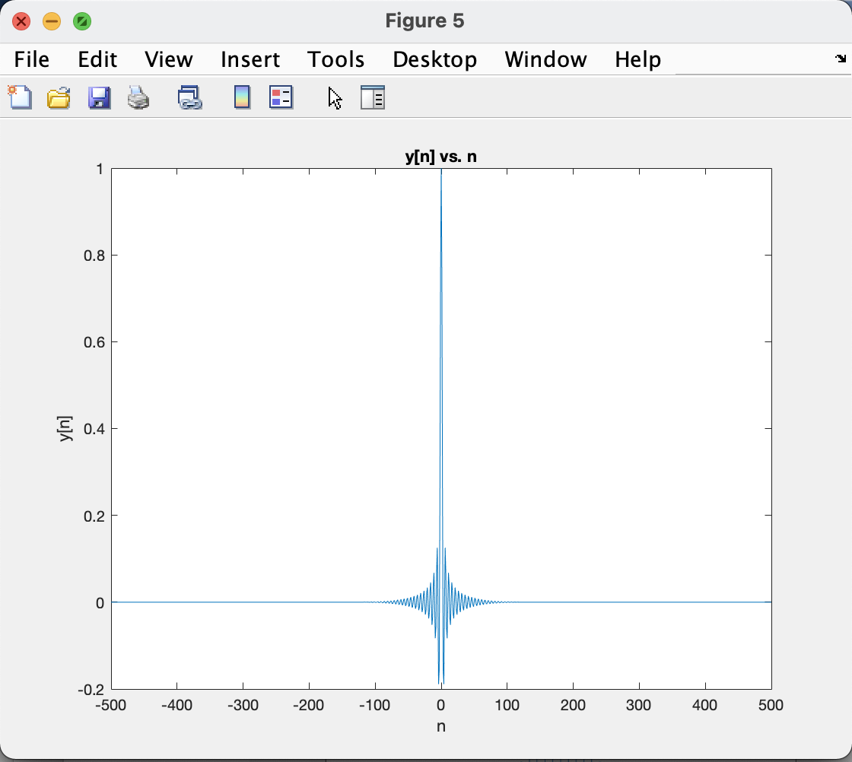

**(f) Figure** fft of y[n] vs. omega :

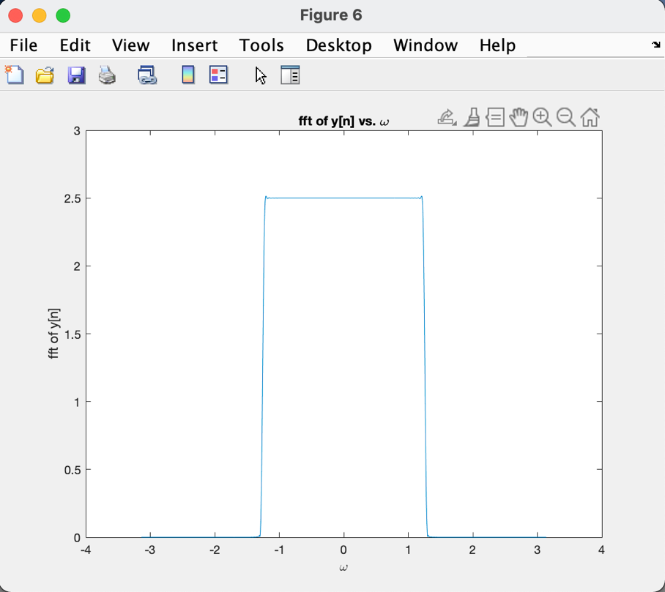

The ripple of the Gibbs Phenomenon after the window function is obviously smaller than the ones in (b), which thanks to the effect of the w(t). I think it’s sort of a LPF, for it need the abs(t) smaller than Tw/2, it will be like a LPF such that the Gibbs Phenomenon is not so obvious.